Autonomous Military Rover:

**We are developing a rugged, high-performance rover designed specifically for military applications. This solution features a 360-degree night vision camera, audio feed capabilities, and GNSS location broadcasting with an integrated GNSS navigation system. The rover is capable of reaching any location autonomously through path planning and Computer Vision, making it ideal for gathering information in situations or locations too dangerous for human personnel.**

**By integrating advanced GNSS navigation and camera feed technologies, the rover provides real-time situational awareness and reconnaissance capabilities across diverse terrains and environments. Additionally, it offers wireless control via RF communication along with autonomous capabilities, allowing operators to view the live feed of camera and Location Coordinates, crucial for maintaining situational awareness.**

**Furthermore, the rover utilizes computer vision and machine learning for obstacle and object detection and reaching the location safely without any external control. This enables the identification of potential threats like fires, water bodies, and even human presence, enhancing overall environmental awareness.**

**There will be present a mountable section where mounts can be installed for various applications. The modular design allows for customization like Fire Fighting, Mine Detection, Robotic Arm, Grenade launcher making the rover adaptable for various missions.**

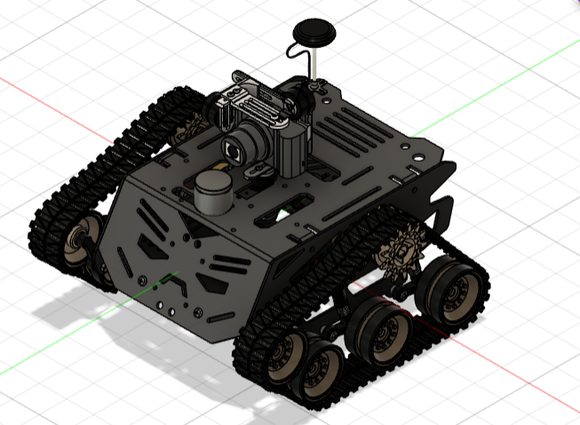

# **Robot Assembly Design:**

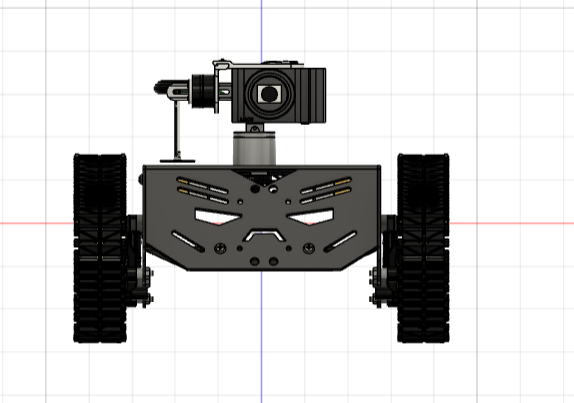 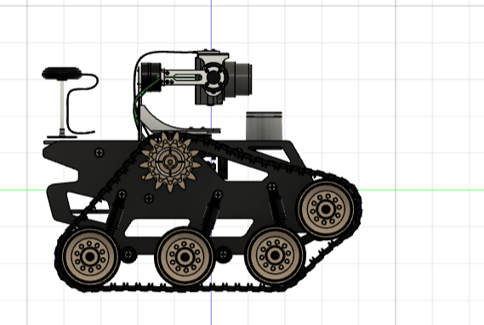

# **Components to be used:**

1. List of Structure components:
2. Rugged Iron Chassis
3. Wheels
4. Belt
5. Batteries
6. List of Motion Components:
7. Chain
8. Suspension
9. List of electronics components:
10. 2-channels ESC
11. NVIDIA Jetson Nano (replaceable with Xavier NX, Intel NUC)
12. PixHawk (based on Ardupilot)
13. 12V DC gear motor x4
14. Battery 18V 6Ah
15. DC-DC regulator 5V 10A
16. 75mm GPS pole
17. Microphone Module
18. LoRa Module (Long Range Receiver and Transmitter)
19. RF Module
20. RF controller Remote
21. Camera Module
22. Microcontroller
23. MPU-6050 (Accelerometer and Gyroscope Module)
24. Obstacle Avoider Sensor
25. LEDs
26. Buzzers
27. LIDAR Sensor
28. List of other Accessories:
29. Mounts
30. Screws and Nuts

# **The methodology of Making Robot:**

**Overall Function:** Autonomous reconnaissance and situational awareness rover for military applications using Autonomous capabilities of Deep Learning and Neural networks for path planning and obstacle avoidance. The Wheels of the Rover are tracks that can easy help us move the rover at **45 degrees incline** as the **surface of contact** in case of tracks are way more than round wheels which will help in **more friction** and **glide easily** **through tall grasses** as well because of the **powerful motors driving the Track of the Rover**.

**Dimensions (estimated):**

* Length: 450mm
* Width: 350 mm
* Height: 200mm

**Weight (estimated):** 20kg (44 lbs)

**Structure:**

* Material: Rugged Iron Chassis (Provides high durability for harsh environments)
* Wheels: All-terrain wheels with high ground clearance (Suitable for uneven terrain)
* Tracks (Optional): Option for interchangeable tracks for increased traction in challenging terrains (Improves manoeuvrability)
* Suspension(Optional): Independent suspension system (Improves stability and handling)

# Application of proposed Robot in a societal context:

Beyond military use, this rugged rover's design could be adapted for search and rescue in hazardous areas (fires, collapsed buildings). Its mobility, sensors, and cameras could help locate survivors and transmit real-time data to aid teams. This technology could be valuable for disaster response and civilian applications as well.

1. Size of Robot proposed for Proof of Concept (Small Version):
2. Length in cm: 30
3. Width in cm: 20
4. Height in cm: 20
5. Size of Robot proposed as prototype (Actual Version ):
6. Length in cm: 45
7. Width in cm: 30
8. Height in cm: 20

# Timeline for Robot Making with milestones. (Divided in activities Vs. no. of days)

**Phase 1: Design and Development (45 Days)** In this phase, the focus is on designing the rover’s structure, selecting the appropriate components, and developing the initial software. This includes creating the chassis, integrating the motors, and setting up the navigation and control systems.

**Phase 2: Prototyping and Testing (90 Days)** This phase involves building a prototype of the rover and conducting extensive testing. The rover’s performance is evaluated under various conditions, and any issues or shortcomings are identified.

**Phase 3: Refinement and Validation (90 Days)** In the final phase, the feedback from the testing phase is used to refine the rover’s design and software. Further testing is conducted to validate the improvements. The rover is finalized and prepared for deployment.

**Total Estimated Timeline:** 225 Days